1.
Prove

2.
Prove by mathematical induction

3.
Prove by mathematical induction

4.
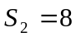 , 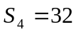 , 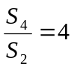

5.
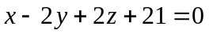
(i) L and M are in 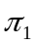.
(ii) 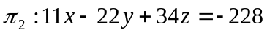
(iii) 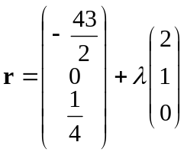

6.
(i) 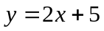 , 
(ii) local minimum point : 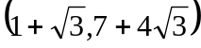 , local maximum point : 